Part 1 individual report:
- Foundations and concepts:

- AI, ML, DL, Generative AI:
I got it P1 presentation.

- Large language models (LLMs) and Transformers:

What is LLMs:
Advanced AI systems called Large Language Models (LLMs) are made to understand, produce, and work with human language. Large textual data sets, including texts from books, journals, websites, and other written sources, are used to train these algorithms. LLMs are able to generate logical and contextually appropriate language by learning the statistical patterns and correlations between words, phrases, and sentences via this extensive training. Because of this, LLMs may carry out a variety of natural language activities, including as responding to inquiries, summarizing documents, translating across languages, writing code, and having conversations with users.

Tokenization in LLMs:
A crucial phase in ensuring the operation of Large Language Models is tokenization. Any text must first be divided into tiny parts called tokens in order for an LLM to understand it. Whole words, subwords, numbers, punctuation, and symbols can all be represented by these tokens. By breaking down linguistic input into understandable components that can be directly analyzed, tokenization enables the model to interpret text effectively. By dividing words into smaller parts, this method also allows LLMs to handle uncommon or unfamiliar terms, guaranteeing strong language comprehension across a variety of inputs.

Embeddings in LLMs:
High-dimensional vectors called embeddings are used to represent the relationships between tokens and their semantic meaning. Unrelated tokens are positioned farther apart in vector space, but symbols with comparable meanings typically have embeddings that are closer together. LLMs are able to understand contextual meaning, identify word similarity, and carry out challenging reasoning tasks because to this representation. In order for LLMs to understand language beyond simple keyword matching, embeddings are essential.

Context window in LLMs:
The maximum number of words that Large Language Models can process at once is determined by the context window. Both the current input and older tokens from earlier sections of the conversation or text are shown in this window. The model's capacity to keep logic, retain previous information, and provide contextually appropriate answers is directly impacted by the size of the context window. Older data may be clipped when the input exceeds the context window limit, which might affect the output's consistency.

What is Transformers:
A deep learning architecture called Transformers was created especially to deal with sequential data, especially natural language. They serve as the fundamental framework for current Large Language Models. Transformers can analyze complete sequences at once, in place of previous sequence-based models that analyzed text word by word. The model is able to recognize relationships between words, even when they are far apart inside a phrase or text, thanks to its parallel processing capacity, which also improves its efficiency. The self-attention mechanism, which allows the model to identify what parts of the input are most relevant for producing a response, is the primary design of Transformers.

Tokenization in transformers:
Since Transformers work with tokenized input, tokenization in Transformer-based systems is based on an idea similar to that of LLMs. Before being analyzed by the model, text is transformed into tokens and mapped to numerical identifiers from an established vocabulary. This stage guarantees that unstructured text can be converted into a numerical representation that is appropriate for deep learning calculations. Tokenization allows Transformers to handle a variety of languages, terminology, and phrase patterns with flexibility.

Embeddings in transformers:
Transformers use embeddings to represent the location and meaning of tokens in a sequence. The semantic information of each token is primarily captured by mapping it to a token embedding. Furthermore, Transformers use positional embeddings to represent a sentence's token order. Positional embeddings are crucial for maintaining word order and sentence structure since Transformers process tokens in parallel rather than sequentially. Transformers provide a deep understanding of both content and sequence by merging token embeddings with positional embeddings.

Context window in Transformers:
The range of tokens that the self-attention mechanism in Transformers may examine together is determined by the context window. Each token has the ability to assess its importance and the importance of other tokens inside this window. Larger context windows increase computational complexity even though they enable Transformers to handle longer texts and retain richer contextual understanding. Although recent developments have offered methods to increase context windows and enhance efficiency for long-sequence processing, real constraints on context size still exist.

Transformers Architecture: it is the main core behind the modern types of LLMs, instead of using a traditional RNN, transformers process entire sequence in parallel.
Its architecture is to have encoder and decoder, the encoder is used for understanding input text, and the decoder is used for generating the new content (output)
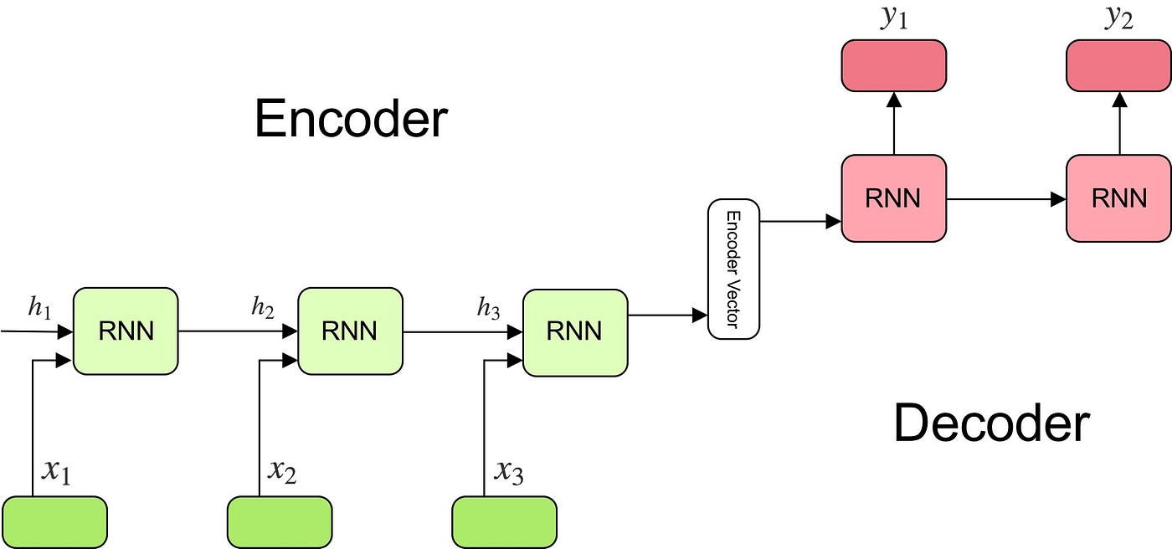

Transformers has a self-attention mechanism, it allows the model to evaluate the importance of each word (as a token) in a sentence compared to the other words, so the model can understand contextual relationships.

- AI agents VS traditional Chatbots:

- AI agents:

What is an AI agent:
AI agents are advanced artificial intelligence that can see, think, plan, and act on their own to accomplish particular objectives. AI agents may make judgments, use external tools, store memory across conversations, and carry out multi-step activities, in addition to basic conversational systems. Large Language Models are frequently used along with other parts like memory modules, planners, and tool interfaces to power them. AI agents are often used in complex real-world applications that need for flexibility and dynamic decision-making.

Architecture of AI agents:
the goal-oriented and modular design of AI agents. A reasoning core (often an LLM), a memory component, a planning mechanism, and tool interfaces make up an AI agent. Before generating a response, the agent first understands the user's objective, then considers the necessary actions, chooses the right tools, and carries them out.

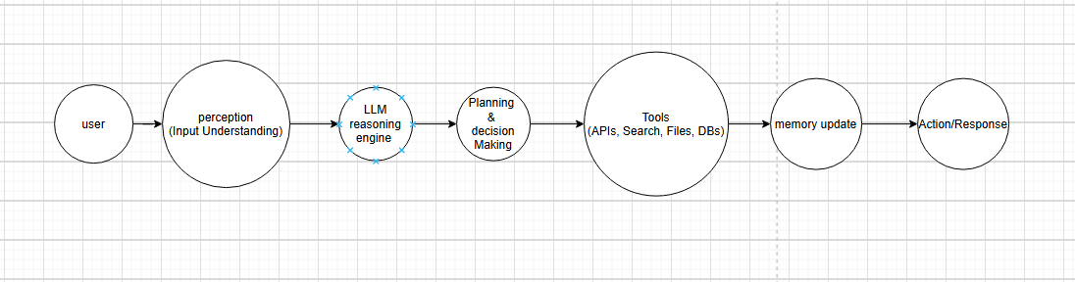

Memory in AI agents:
Both short-term and long-term memory are used by AI agents.
While long-term memory keeps information between sessions, such as user tastes, past tasks, or learned habits, short-term memory preserves the present conversational environment. This makes it possible for AI agents to provide customized interactions and get better over time.
Tools used by AI agents:
The idea that AI agents are enhanced tool systems is a crucial slide. AI agents are capable of calling other tools like online search engines, databases, file systems, calculators, and APIs, in contrast to basic chatbots. Instead of depending solely on pre-trained information, the use of tools enables agents to get real-time data, carry out calculations, and communicate with external systems.

Multi-step planning in AI agents:
Multi-step planning is supported by AI agents. The agent breaks down a job into several phases, completes them in order, assesses the intermediate outcomes, and modifies its approach as necessary. Instead of responding in a single turn, agents may manage intricate processes because to this planning capacity.
Multi-step planning steps:
- Goal understanding:
First, the agent determines the user's true desires. From the user request, it determines the primary goal, limitations, and success criteria. Because planning depends on having a clear goal, an agent may ask a clarification query if the request is unclear.

- Task decomposition:
The agent divides the objective into smaller, more manageable tasks after comprehending it. It divides the effort into smaller tasks like "collect information," "analyze," "generate output," and "verify" rather than attempting to address everything at once.

- Planning and sequencing:
The best sequence for carrying out the steps is then determined by the agent. The agent creates a logical sequence since certain tasks are dependent on others (for instance, retrieving data is necessary before summarizing it). Instead of making a single reaction, the agent creates a "plan" at this stage.

- Tools selection:
If task requires external tools the agent chooses the best tools for each subtask:
- Search or retrieval (to get fats and info)
- Computations
- Database/file reader (to retrieve stored information from the database)
- API calls (to interact and communicate with the system)

- Execution:
Agents act step-by-step in the plan that it initiated earlier, they might call tools, read results, then move to the next step the execution of iterative, the agents complete each task individually step by step then use the output if the current sub-task in the next one.

- Observation and evaluation (to check the results):
The agent evaluates if the result makes sense and advances the objective after every action. Instead of continuing without thinking, the agent detects when a tool gives an error, incomplete data, or poor results.

- Refinement/ replanning (to fix and improving):
If the previous step (sub-task) gave a false result or failed the agent adjust the current plan by:
- Choosing different tools
- Trying another strategy
- Requesting the user to give more information
- Rearrange the current arrangement of steps

- Memory update (to store important information):
The agent stores important information in memory (maybe long-term for further exchanges, perhaps short-term for the current conversation). In order to make next tasks quicker and more individualized, this may include user requirements, effective solutions, or important choices.

- Final response (output and next actions):
The final answer is then generated by the agent in the format that was requested. In many agent systems, the output includes the next suggested action in addition to the response.

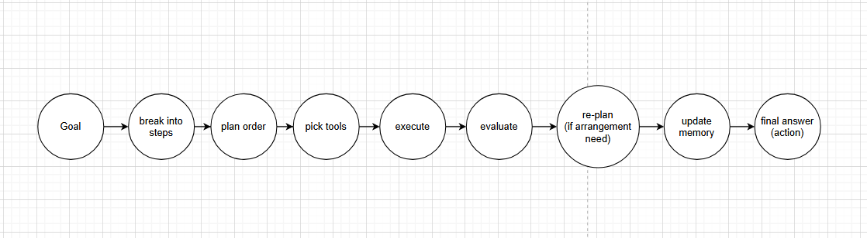

Example use cases of AI agents:

AI agents are used in scenarios that require autonomy and reasoning, such as intelligent virtual assistants, autonomous research agents, workflow automation systems, decision-support agents, and enterprise AI systems that manage data analysis, reporting, or scheduling tasks.

Feature | AI agent
Architecture | Modular, goal-driven
memory | Short-term and long-term
tools | Extensive tool usage
Multi-step planning | It does multi-step planning
Use cases | Automation, research, intelligent assistant

- Traditional chatbots:

What is a traditional chatbots:
Traditional chatbots, are rule-based or intent-based conversational systems designed to respond to predefined user inputs. rather than using logic or planning, they match user queries to pre-existing patterns and provide answers that are predefined. Automating basic interactions is their main goal.

Architecture of traditional chatbots:

Conventional chatbots have a linear and reactive design. A rule engine or purpose analyzer receives user input and chooses a suitable answer from a predefined rules. Automated decision-making, a planning component, and a reasoning layer are unavailable.

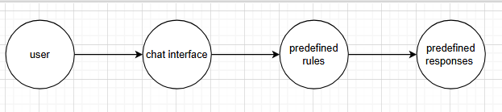

Memory in traditional chatbots:

Traditional chatbots don't have much memory. During a single interaction, they could recall barely any context, but when the session is over, all of the information is gone. As a result, there is no long-term customization and only recurring exchanges.

Tools used by traditional chatbots:

Traditional chatbots typically do not use external tools. Their responses are limited to predefined scripts or simple database lookups. Any updates or new functionality require manual programming.

Muti-step planning in traditional chatbots:

Multi-step planning is not supported by traditional chatbots. The chatbot cannot execute reasoning across stages or divide tasks into smaller tasks; instead, each user inquiry is evaluated separately.

Example use cases of traditional chatbots:

traditional chatbots are mainly used for FAQ systems, basic customer support, appointment booking

feature | Traditional chatbots
Architecture | Rule-based
Memory | none
tools | Very limited
Multi-step planning | No
Typical use cases | FAQ

2.Use case analysis and requirements:
Use case analysis:
An AI Gym Personal Trainer (PT) Assistant is the chosen use case for this generative AI system. Through a conversational chatbot interface, this assistant helps people who workout by offering exercise advice, suggestions for training splits, and nutritional assistance.
This use case is feasible because many gym trainees particularly beginners and intermediate users find it difficult to choose efficient training plans, appropriate exercises, and safe diets in order to accomplish objectives like body recomposition, muscle development, or loss of fat. Users may communicate with the assistant in normal language and easily get organized fitness advice rather than looking through several sources. Because the system can be used in both Arabic and English, a larger audience can use it and it is appropriate for practical applications.

Requirements:
- User requirements:
- Functional user requirements:

- The user can ask questions about several gym workouts
- The user can request a personalized splits based on his or her activities
- The user can ask for nutrition advice
- The user can communicate either in English or Arabic
- The user can ask follow-up questions continuously
- The user can clear the conversation
- The user can retrieve his or her personal information
- If the user ID does not exist, the user can create a new personal profile
- The user only receives answers related to gym and nutrition. Any other questions will be rejected politely
- If the user requests unsafe or harmful aggressive request the assistant will refuse to and will provide a warning message

- Non-functional user requirements:

- The system should be easy to use for all users
- The system should provide clear and easy to read responses
- The assistant must remain understandable in both Arabic and English
- The system should run without crashing

- System requirements
- Functional system requirements:

- The system must be connected to an LLM service
- The system must implement prompt engineering rules to frame the responses to only be related to gym workouts and nutrition advice
- The system must understand the request of the user and classify the request
- The system must retrieve the user’s information from a dataset
- The system must allow the user to add new user if the user is not available
- The system must store the conversation history in a csv file
- The system must log and save each interaction interacrion_logs.csv
- The system must include a safety filter to detect aggressive diet prompts and refuse them.

- Non-functional system requirements:

- API key must not be hard coded in public repositories; the system should support .env files. For security
- The code should be modular including separate functions for logging, categorization and API calls. For maintainability
- The system should give responses within a reasonable amount of time. For performance
- The system should allow new adding for users without crashing the system. For scalability
- The system must refuse harmful requests if the user ask for such requests. For ethical compliance
- CSV file updates must be consistent and done correct without losing previous data. For data integrity

- Python and data preparation:
- Tools and libraries:
Pandas: reading csv files, cleaning, validation, saving enriched datasets
Numpy: numerical calculations
Matplotlib: to generate plots
CSV and Datetime: saving logs with timestamp
Streamlit: creating user interface

- Dataset loading using pandas:


- Data cleaning (standarizartion) key categorical fields are standardized by converting to lowercase and removing spaces: using dataframe pandas:
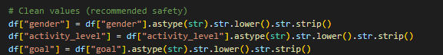
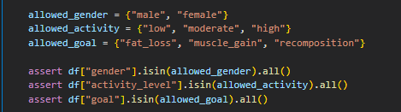

- Tools and feature engineering:
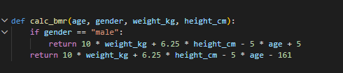
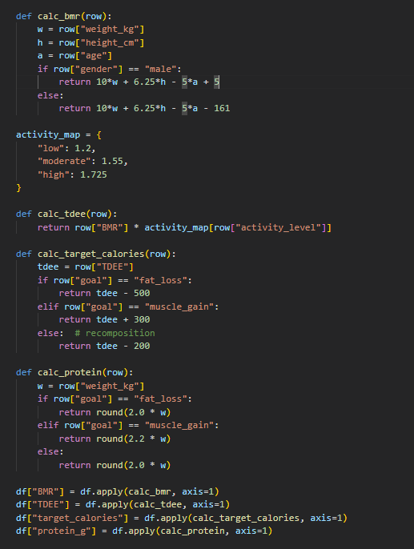

- Visualization using Matplotlib:
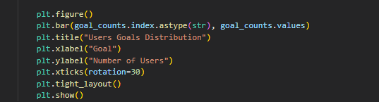
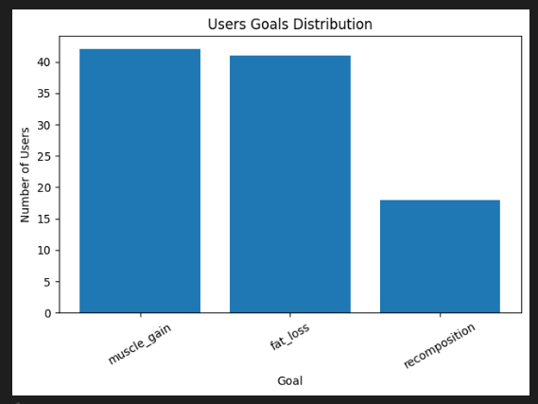

- System and agent architecture design:
The system is an AI gym personal trainer agent that allows users to connect and communicate using a graphical interface
It connects the Groq LLM API so it can generate responses and it stores the users profiles and interaction logs.

The Gym pt AI agent consists of 4 layers:
- User interface (streamlit web application):
- It provides a chat interface
- Allow the user to create a profile
- Support chat history and clear chat button
- Allows the users to enter their user ids so they can load their saved information

- Backend logic:
- Detect the language from the questions asked
- Classify the question category from the question itself (workout, nutrition, meal plan, profile retrieval)
- Apply safety rules if users ask for aggressive diets
- Build the correct prompts before calling the LLM API

- LLM service Groq API Llama model:
- generates responses based on the user questions
- Use multi-turn conversation history stored in session state

- Data storage and logging (using csv files):
- stores user profiles and nutrition targets (BMR, TDEE, calories, protein)
- stores each chat interaction with timestamp, user_id, input, response, category, and language.

Block diagram (architecture of the gym pt AI agent):

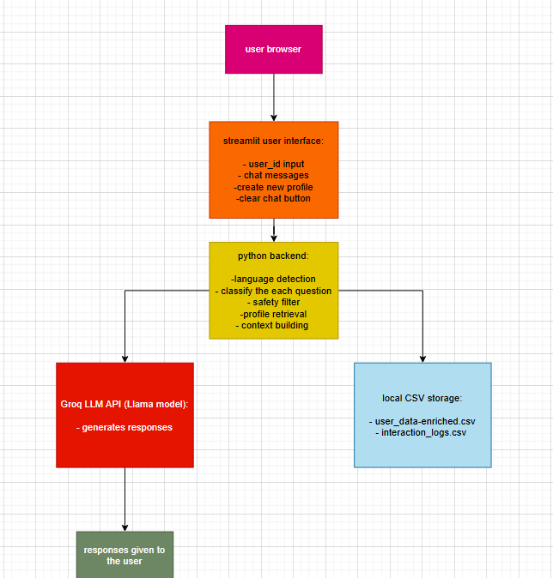

The process of one message:
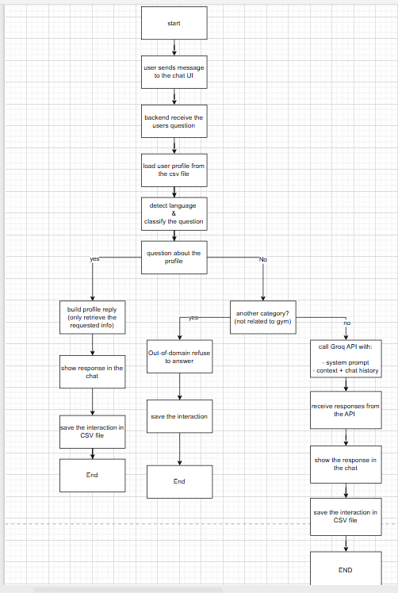

Agent behavior in the system:
- Even though this is a chatbot, it demonstrates agent-like workflow behavior because it performs multi-step decision logic before calling the LLM, including:
- Tool-like retrieval from local user dataset (users_data_enriched.csv)
- Example: If the user asks “my height” → the system retrieves height only from the dataset.Safety filtering and refusal rules
- Example: If the user asks for crash diet or extremely low calories → the agent refuses and explains side effects.
- Multi-turn conversation memory
- Uses Streamlit st.session_state.chat to maintain back-and-forth conversation.
- Structured prompt engineering
- Uses a system prompt enforcing strict domain boundaries and structured answers.

- Prompt engineering strategies:

To specify its function as an AI Gym Personal Trainer and manage the response behavior, the assistant uses a strict prompt. Clear guidelines are enforced by the system prompt, including responding just the questions asked by the user, separating questions about exercise from questions about nutrition, rejecting issues outside of its scope, avoiding from offering medical advice, and alerting users if they ask for dangerous "crash diet" programs. This design follows to the prompt engineering concept, which states that in order to improve the accuracy, focus, and safety of the AI output, better prompts need precise instructions, strong context, and particular limitations.

Pattern 1 (Instructional Prompts (Direct command-based prompts):

Instructional prompts are used when the user gives a direct request like “Give me a workout plan” or “Calculate my calories.” This fits the instructional style where the user clearly tells the model what action to perform, which improves accuracy and task completion.

Examples:
- give me a push day workout for muscle gain
- how many calories should I eat for fat loss
- make me a meal plan for 3 days

Pattern 2 (Role-Based):
The project uses persona prompting through the system prompt, which gives the model a constant identity: AI Gym PT, even if the user does not specifically state "act as..." This enhances domain control, tone, and consistency, which aligns with the idea of using persona and structured context to better AI communication.
Examples:
- coach me like a personal trainer and tell me what to do today
- you are my personal trainer make me a plan based on my goal

Pattern 3 (Conversational Prompts):
Because the system is designed to function as a chat assistant in Streamlit, conversational cues are used. Conversational prompting that facilitates dynamic, chatbot-style engagement works well since the user naturally engages in several turns.
Examples:
- I trained yesterday and I feel sore, what should I do today
- I do not know if I should bulk or cut

Pattern 4 (Context-Structured Prompts):
User context (age, gender, weight, goal, and nutrition goals) is automatically included into the LLM request by the system. This is in line with the concept of "context structuring," which holds that prompts become stronger when they incorporate limits and background knowledge, leading to more useful results.
Examples:
- minimal profile context for workout guidance
- nutritional context (TDEE + target calories + protein) for diet answers

Naïve prompts vs Improved prompts:
The output becomes general and does not meet the user's actual needs when a naïve prompt is too brief or lacks specifics. Improved prompts offer more precise context and guidance, resulting in higher quality output, whereas naïve prompts frequently produce ambiguous outcomes.

Naïve prompts:
“Give me a workout.”
Result: The assistant may respond with a general routine that might not match the user’s goal, available time, or experience level.

Improved prompts”
“Give me a Push workout for muscle gain, 60 minutes, beginner-friendly, with dumbbells only.”
Result: The response becomes more personalized, structured, and practical, because the model receives clear constraints and a defined objective.

Advanced prompting techniques:
The interview-style approach is one advanced prompting technique used in this research, in which the assistant responds to the user's request and uses stored profile information (such as age, weight, height, activity level, and aim) only when relevant. Conversations about the gym become easier and more productive as a result of the increased customization and decreased repetitive inquiry.

Nevertheless, this system did not fully utilize advanced prompting techniques. A complete follow-up questioning mode, for instance, involves the assistant actively asking many clarifying questions without providing any response in order to gather any missing information and ensure optimum correctness. This may slow down the conversation and make it less useful in brief fitness talks, even though it can result in highly customized replies.
Chain-of-Thought (CoT) prompting, which promotes methodical thinking for challenging tasks, is another strategy that was not used. CoT frequently results in lengthier and less straightforward answers, even if it can increase accuracy in multi-step situations like precise meal planning and numerical computations. This assistant concentrates on brief organized responses rather than producing lengthy reasoning outputs because it is intended for quick and useful gym assistance.

- Ethical and social considerations:

Concerns:

- Because the LLM sometimes produces confident responses that are incorrect or false, imagining is a major concern in this effort. In the context of fitness, this might lead to users following to false nutritional advice, dangerous exercise technique, or incorrect training suggestions, which could result in injuries or poor performance.

- Another significant ethical concern is the over-reliance on AI, as some users could treat the chatbot like a doctor or even a professional coach. An AI system cannot take the role of professional human judgment in health-related situations, therefore this is dangerous if the user has a medical condition, accident, or requires specialist support.

- Because the system tracks the chat history and retains user profile data including age, weight, height, exercise level, and goal, privacy is an important concern. These logs or datasets might reveal private information and affect user confidence if they are abused, shared, or made public.

- Unsafe nutritional information provides a significant risk as well, particularly when users ask for extreme weight loss plans, extremely low calorie diets, or aggressive diets. These suggestions may promote bad habits, result in nutritional mistakes, and create long-term problems including tiredness, muscle loss, and regain obesity.

- Bias and unfairness can appear if the system responds differently based on user attributes like gender, age, or activity level, or if the dataset's basis assumptions are unbalanced. This might lower the assistant's fairness and trustworthiness and result in suggestions that are less accurate for some groups.

Mitigation:

- Strict domain filtering is used by the assistant to reduce these risks, so it only answers questions about diet, exercise, and the gym and ignores other subjects. This reduces the possibility that the model may provide incorrect recommendations outside of the project's scope.

- The system uses a powerful diet detection filter that prevents requests for extreme diets and provides a warning message outlining negative side effects in an effort to minimize unsafe dieting behavior. Additionally, it recommends safer substitutes such mild calorie deficits combined with strength training.

- In order to prevent medical abuse, the system includes quick restrictions that prevent the assistant from functioning as a healthcare professional and avoids providing medical advice by design. This promotes responsible use and keeps the system within safe bounds.

- The project employs logging mostly for evaluation and limits saved profile information to what is required for fitness personalized in order to mitigate privacy. Sensitive characteristics should be eliminated, access should be limited, and logs should be anonymized in actual deployments.

- Through targeted responses and multi-turn conversation handling that is, the assistant just responds to the user's questions without providing unnecessary information the system enhances usability and decreases misunderstanding. This reduces miscommunication, enhances the user experience, and gives the assistant a sense of security and control.

- Implementation and deployment summary:

Implementation:

- Python:
Python was the primary programming language used in the implementation of this system. The whole backend logic of the assistant, including taking user input, applying decision rules, contacting the LLM API, and organizing the chat history, was constructed using Python.

- Streamlit:
Streamlit, which offers an easy and engaging web-based chat environment, was used to create the user interface. Streamlit was selected because its browser interface, which includes multi-turn conversation behavior, straightforward chat capabilities, and user profile creation, makes it simple for non-technical people to engage with the chatbot.

- Groq LLM API:
The official Groq Python module was used to link the chatbot generating engine via the Groq LLM API. Prompts, user context, and previous conversation messages are sent to the Groq model by the system, which then receives answers and shows them in real time inside the Streamlit chat interface.

- Pandas:
The assistant loads and manages CSV-based user profile data using Pandas. Pandas is used to retrieve user data, update the dataset when new users are added, and allow assessment by loading the interaction logs. The dataset is kept in users_data_enriched.csv.

- Matplotlib:
Matplotlib is also used in the project to create evaluation visualizations. Plots showing the distribution of user ages, the top active users, or any other basic performance/usage insights needed for the assignment may be produced by analyzing the logged interactions kept in interaction_logs.csv.

Deployment:
- Local streamlit web application:
The AI Gym PT Assistant was implemented as a local Streamlit web application, which means it launches within a web browser on the user's computer. The project files (Streamlit app file, enriched dataset, and log file) were saved in a single folder, the necessary Python libraries were installed, and the program was launched using the command streamlit start app.py. Following the execution of this command, Streamlit instantly launches a local server (localhost) and offers a link that launches the chatbot interface in the browser, enabling the user to communicate with the assistant via a straightforward chat experience.

- Groq LLM API:
The official Groq Python module was used to link the assistant to the Groq LLM API. Based on the system prompt, user context, and conversation history, this API is in charge of producing the personal trainer replies. The assistant cannot interact with the LLM service without the API key, which is necessary for authentication. The approach allows the API key to be stored either directly in the code for testing or in a.env file for better security practices, making deployment both feasible and secure.

Sensitive data, such API keys, may be safely stored in the.env file without being hardcoded into the project. The dotenv library is used to load the key at runtime in this project, and the.env file has the line GROQ_API_KEY=your_key_here. Because the API key is hidden within the source code and it is simpler to update the key without changing the application file, this method increases security. Additionally, this approach follows to recommended practices for implementing systems that depend on external APIs.

Testing:
To verify that the system functions well , the assistant was put through a number of genuine user interactions. The Streamlit program was used for testing, and several types of questions, including those on exercise, nutrition, meal plans, and profile retrieval, were asked. The assistant presented the user messages and the AI replies in a back-and-forth chat format while effectively maintaining a continuous multi-turn discussion.
In order to confirm language support and accurate Arabic input identification, the system was additionally tested in both Arabic and English. Additionally, aggressive or crash-diet-related suggestions were submitted as part of special safety testing. The assistant successfully rejected these requests and presented a warning message outlining potential negative effects. In order to uphold domain constraints, the assistant appropriately declined inquiries that went outside the scope of the gym and nutrition in another crucial test case.
To make sure each interaction is saved in the interaction_logs.csv file, logging tests were lastly carried out. This demonstrated that the system can facilitate review and analysis in the future, where system utilization, user activity, and assistant behavior can be studied by loading interaction logs using Pandas and visualizing them using Matplotlib.

- Github links and references:

https://github.com/FerasJalal/ai_gym_ot_agent/tree/main

References:
Bishop, C.M. (2006) Pattern Recognition and Machine Learning. New York: Springer.
Brown, T.B., Mann, B., Ryder, N., Subbiah, M., Kaplan, J., Dhariwal, P., Neelakantan, A., Shyam, P., Sastry, G., Askell, A., Agarwal, S., Herbert-Voss, A., Krueger, G., Henighan, T., Child, R., Ramesh, A., Ziegler, D., Wu, J., Winter, C., Hesse, C., Chen, M., Sigler, E., Litwin, M., Gray, S., Chess, B., Clark, J., Berner, C., McCandlish, S., Radford, A., Sutskever, I. and Amodei, D. (2020) ‘Language models are few-shot learners’, Advances in Neural Information Processing Systems (NeurIPS), 33, pp. 1877–1901. Available at: https://arxiv.org/abs/2005.14165 (Accessed: 26 January 2026).
Devlin, J., Chang, M.-W., Lee, K. and Toutanova, K. (2019) ‘BERT: Pre-training of deep bidirectional transformers for language understanding’, Proceedings of NAACL-HLT 2019, pp. 4171–4186. Available at: https://arxiv.org/abs/1810.04805 (Accessed: 26 January 2026).
Goodfellow, I., Bengio, Y. and Courville, A. (2016) Deep Learning. Cambridge, MA: MIT Press. Available at: https://www.deeplearningbook.org/ (Accessed: 26 January 2026).
Jurafsky, D. and Martin, J.H. (2023) Speech and Language Processing (3rd ed. draft). Available at: https://web.stanford.edu/~jurafsky/slp3/ (Accessed: 26 January 2026).
Mitchell, T.M. (1997) Machine Learning. New York: McGraw-Hill.
OpenAI (2024) GPT-4 Technical Report. Available at: https://arxiv.org/abs/2303.08774 (Accessed: 26 January 2026).
Radford, A., Narasimhan, K., Salimans, T. and Sutskever, I. (2018) ‘Improving language understanding by generative pre-training’. OpenAI. Available at: https://openai.com/research/language-unsupervised (Accessed: 26 January 2026).
Russell, S. and Norvig, P. (2021) Artificial Intelligence: A Modern Approach. 4th edn. Harlow: Pearson.
Sutton, R.S. and Barto, A.G. (2018) Reinforcement Learning: An Introduction. 2nd edn. Cambridge, MA: MIT Press. Available at: http://incompleteideas.net/book/the-book-2nd.html (Accessed: 26 January 2026).
Vaswani, A., Shazeer, N., Parmar, N., Uszkoreit, J., Jones, L., Gomez, A.N., Kaiser, Ł. and Polosukhin, I. (2017) ‘Attention is all you need’, Advances in Neural Information Processing Systems (NeurIPS), 30, pp. 5998–6008. Available at: https://arxiv.org/abs/1706.03762 (Accessed: 26 January 2026).
Weng, L. (2023) ‘LLM-powered autonomous agents’. Available at: https://lilianweng.github.io/posts/2023-06-23-agent/ (Accessed: 26 January 2026).
Yao, S., Zhao, J., Yu, D., Du, N., Shafran, I., Narasimhan, K. and Cao, Y. (2023) ‘ReAct: Synergizing reasoning and acting in language models’, International Conference on Learning Representations (ICLR 2023). Available at: https://arxiv.org/abs/2210.03629 (Accessed: 26 January 2026).

Groq. (2025) *Groq Python SDK Documentation*. Available at: https://github.com/groq/groq-python (Accessed: 26 January 2026).
Streamlit. (2025) *Streamlit Documentation*. Available at: https://docs.streamlit.io/ (Accessed: 26 January 2026).
Pandas Development Team. (2025) *pandas Documentation*. Available at: https://pandas.pydata.org/docs/ (Accessed: 26 January 2026).
Hunter, J.D. (2007) ‘Matplotlib: A 2D graphics environment’, *Computing in Science & Engineering*, 9(3), pp. 90–95. doi: 10.1109/MCSE.2007.55.
Python Software Foundation. (2026) *Python 3 Documentation*. Available at: https://docs.python.org/3/ (Accessed: 26 January 2026).
Groq. (2025) *Llama 3.3 Model Support (Groq Platform)*. Available at: https://console.groq.com/docs (Accessed: 26 January 2026).
OpenAI. (2025) *Prompt Engineering Best Practices*. Available at: https://platform.openai.com/docs/guides/prompt-engineering (Accessed: 26 January 2026).

